**How to use**

**SS49E Linear Hall-Effect Sensor**

1. Description

2. Wiring

3. Upload sample code

4. How to interpret the reading

# 

# **1. Description**

**It can measure both north and south polarity of a magnetic field and the relative strength of the field.**

# 

# **2. Wiring**

1. VDD → 3V

2. GND → Ground

3. OUT → A0

# 

# 

# 

# 

# 

# 

# 

# 

# 

# 

# 

# 

# 

# **3. Upload sample code**

|  |
| --- |
| int mag_strength; int sensor_pin = A0;  void setup() {  Serial.begin(9600); }  void loop() {  mag_strength = analogRead(sensor_pin);  Serial.print("Magnetic field strength is: ");  Serial.println(mag_strength);  delay(200); } |

# **4. How to interpret the reading**

**If no magnet is present, reading is at constant vale, around 300.**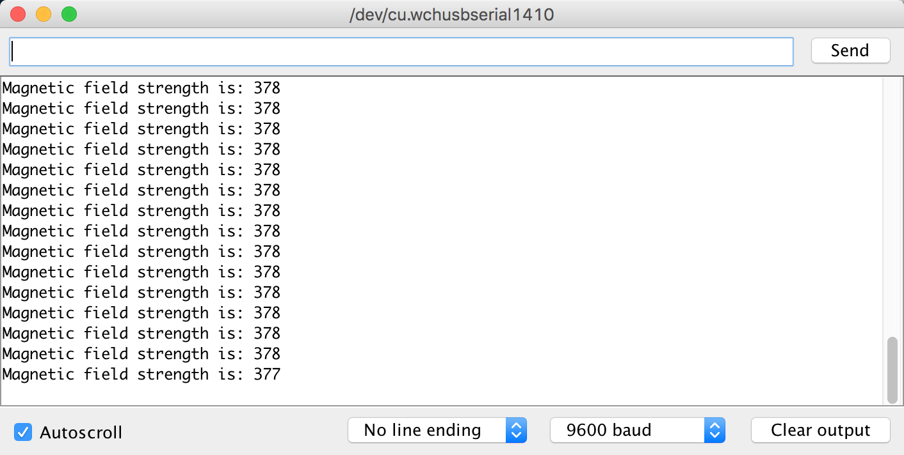

**If the north pole of the magnet is close, reading will go above the stable value (378).**

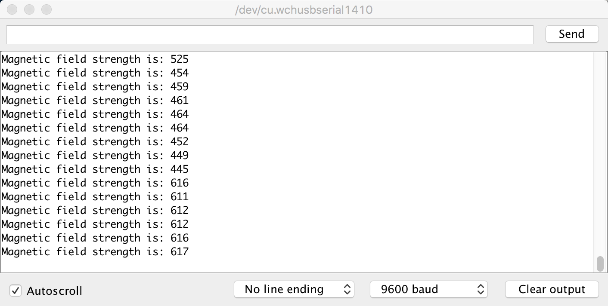

**If south pole of the magnet is close, reading will go below the stable value (378).**